Victorian Curriculum F–10 links:
Levels 5 and 6
Science
Science Understanding
Science as a Human Endeavour
Scientific understandings, discoveries and inventions are used to inform personal and community decisions and to solve problems that directly affect people’s lives
Chemical sciences
Solids, liquids and gases behave in different ways and have observable properties that help to classify them

Activity: Treating sewage sustainably (Years 5 and 6)
  - From past to present—at the Western Treatment Plant
Students investigate the sustainable practices used at the Western Treatment Plant and the related benefits and impacts on society and the environment.

Duration
Two-hour session

Equipment
Interactive whiteboard or data projector

Activity steps
- Discuss the term ‘sustainable’; this is a complex term for students to understand. Begin with brainstorming words or phrases that relate to being sustainable. Lead students to the understanding that sustainability is the wise use of resources, minimising waste and ensuring resources for future generations.
- Explore the Melbourne Water web page that explains the community and environmental benefits of the Western Treatment Plant. Ask students to list the ways in which the Western Treatment Plant is working towards being sustainable. Ideas include:
- methane gas is captured to power the plant
- dried-out sludge (biosolids) is used as fuel, road beds or soil for landscaping
- water is recycled in the process of treating the sewage
- water enters the atmosphere through evaporation and can return to the ground as rain
- a natural process is used to treat our sewage
- the wetland provides habitat for water birds.
- Ask students to choose an area of interest and find out more about the processes at the Western Treatment Plant that help us to live more sustainably.
- Use the following process to find out more about sustainable practices.
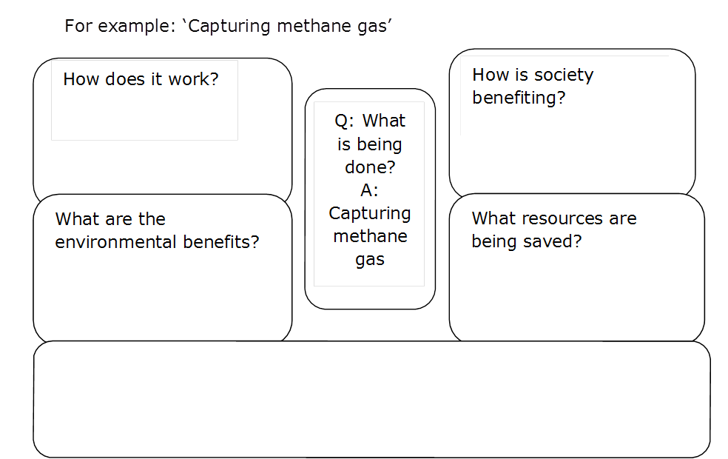
- Share students’ ideas about the sustainable practices identified and elaborated using the above inquiry method.
- Ask students to reflect on ways that they can become more sustainable with their own water use.

Victorian Curriculum and Assessment Authority (VCAA) <http://victoriancurriculum.vcaa.vic.edu.au/> Accessed 14 August 2016.

